Air Quality
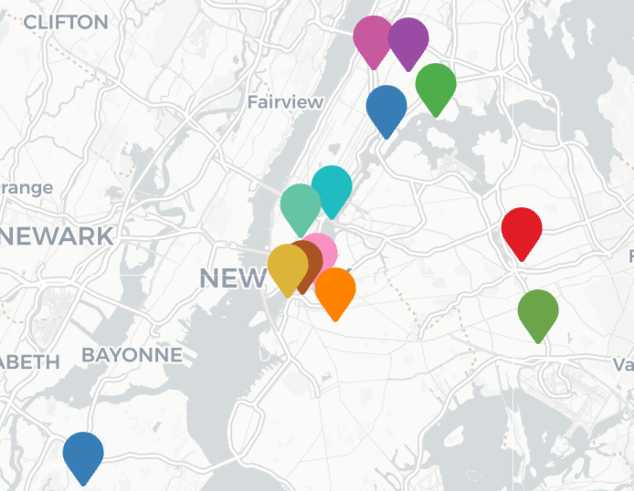
There are only 14 PM2.5 sensors in all of New York City, which presents difficulties when comparing air quality between different neighborhoods.
Additionally, areas with the worst air quality do not also have the worst air quality-related health impacts.
The greatest potential to improve public health lies in policies that address the negative health impacts of air quality, and how it is inequitably distributed across the city, rather than air quality itself.

Air Quality Impacts
Data Sources
- New York City Community Health Profiles
- Councilcount for demographics
- Housing Maintenance Code Violations

Analysis
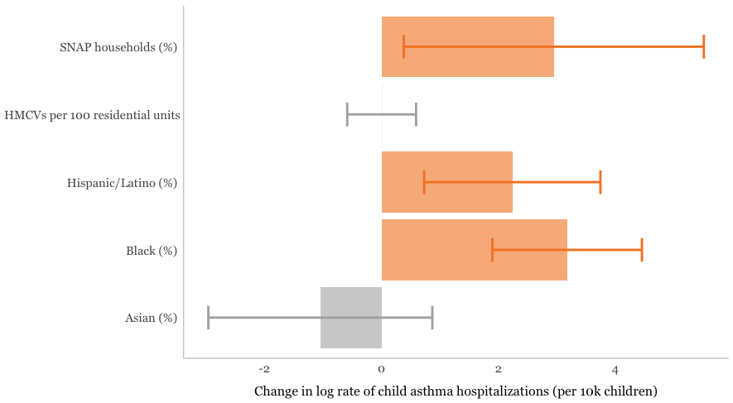
At the community district level, % of households receiving SNAP, % Hispanic/Latino, and % Black were demographic factors found to be statistically significantly associated with increased rates of child asthma hospitalizations.
Although there is an established relationship between housing characteristics, such as moisture and mold, pest and rodent infestations, secondhand smoke, volatile organic compounds (VOCs), and inadequate ventilation, and asthma, the rate of housing maintenance code violations (HMCVs) was not found to be statistically associated.
Key neighborhoods
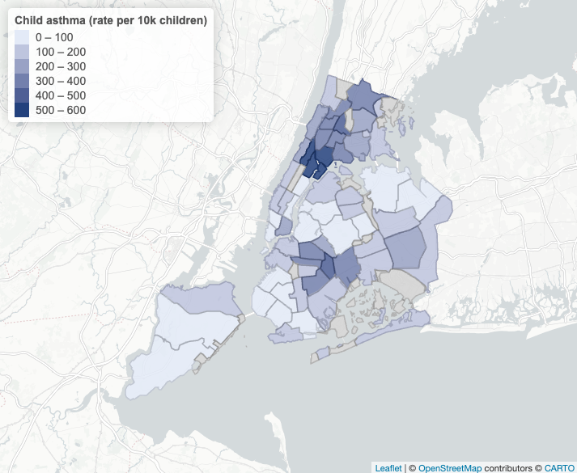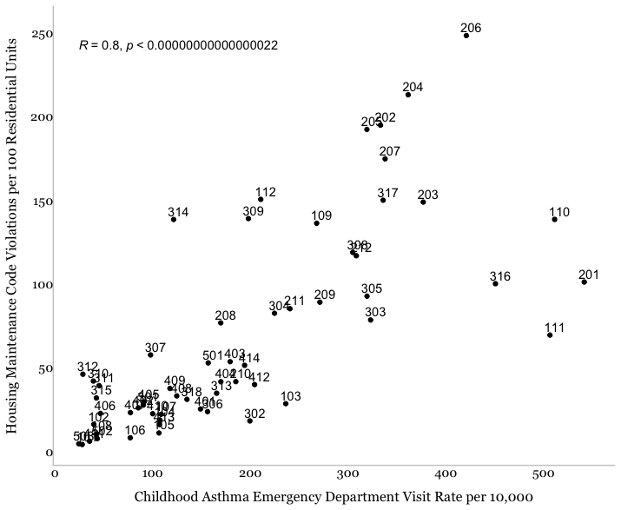
Children living in the Bronx and parts of Upper Manhattan experience the highest rates of hospitalization for asthma cases, as well as a lower rate of HMCVs in comparison to other similarly situated districts – potentially highlighting the need for further intervention. The top community districts for childhood asthma include:
Mott Haven and Melrose (CD1, 201): 541.4 hospitalizations per 10k children
Central Harlem (CD10, 110): 511.1 hospitalizations per 10k children
East Harlem (CD11, 111): 506.3 hospitalizations per 10k children
Brownsville (CD16, 316): 450.6 hospitalizations per 10k children

